**3D Object Detection and Sensor Fusion for Autonomous Driving in the DEKOR-X Project**

As part of the DEKOR-X project on autonomous and connected driving, this work focuses on long-term stable 3D object detection using Lidar and camera sensors under varying weather conditions. It involves designing and deploying a perception system at a real intersection, including sensor procurement, calibration (intrinsic and extrinsic), and installation. A custom data collection pipeline was developed to create a novel fusion dataset for 3D object detection. The project emphasizes Lidar-based perception, complemented by camera data, to handle domain shifts effectively. Additionally, state-of-the-art detection algorithms like PointPillar were trained and fine-tuned on the collected dataset.

Two Ouster LiDARs and four Basler GigE cameras were deployed to capture complementary sensor data. In autonomous driving, LiDAR and camera sensors offer unique strengths, and their integration requires precise extrinsic calibration. This work uses an interactive, target-based calibration tool that employs ArUco markers to align 3D LiDAR points with camera pixels. The open-source tool achieves sub-pixel reprojection accuracy and supports both high and low-resolution sensors. More details and code are available at: <https://github.com/tui-abdul/3d_lidar_camera_calib>. [1]



**Real-Time Behavioral Prediction and Bio-Signal Analysis in the CCSR Project**

As a scientific researcher at the University of Bremen, I contributed to the **Cognitive Control of Social Resonance (CCSR)** project by developing a JavaScript-based application using the JsPsych framework for behavioral data collection. The project involved building a multi-modal dataset and conducting large-scale video data analysis of bio-signals using tools like FFmpeg and OpenFace. A real-time machine learning pipeline was implemented to predict behavioral states from video and speech inputs. This work supports advancements in mental health monitoring, social cognition research, and human-computer interaction**.**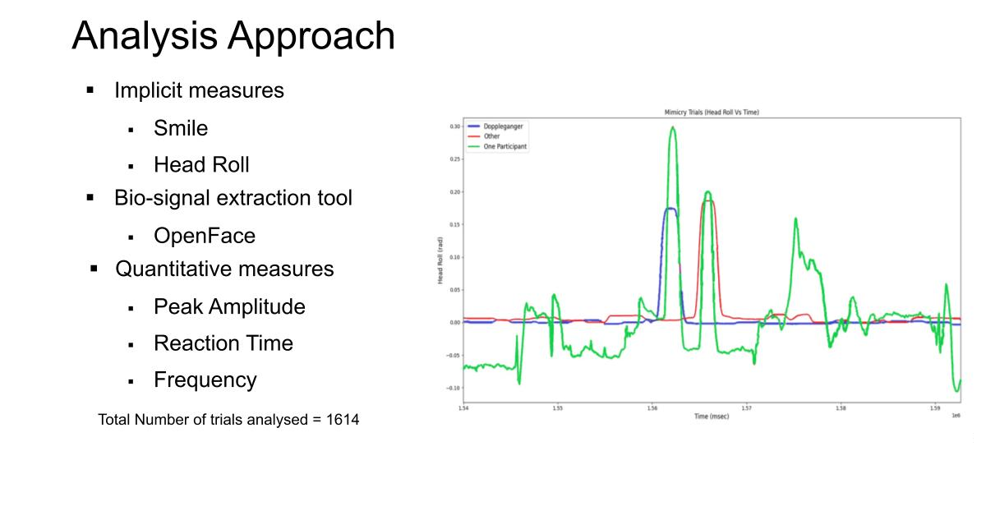

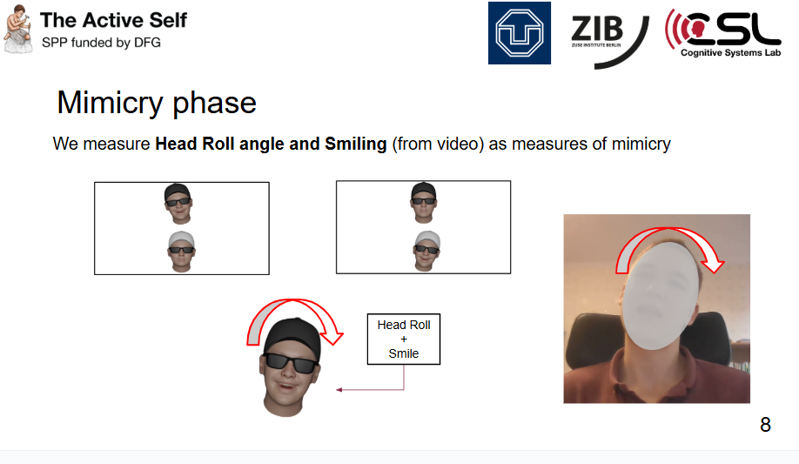

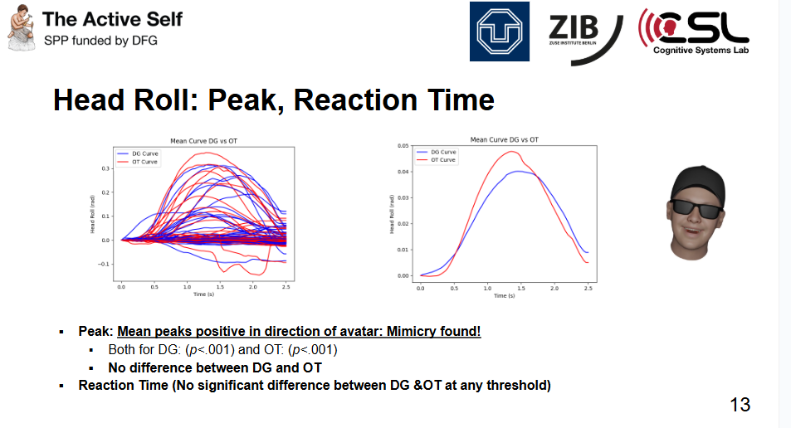

<https://github.com/tui-abdul/exp-1_ccsr>

**Anomaly Detection and Fault Diagnosis of EV Gearbox Using NVH Data**

As part of a master thesis with Fraunhofer IDMT and Schaeffler AG, I developed Multilayer Perceptron and LSTM Autoencoder models for anomaly detection in Audi e-tron NVH data, achieving 82–90% accuracy. The project involved dimensionality reduction using T-SNE and clustering with DBSCAN for identifying patterns and faults. The goal was to detect gearbox anomalies using acoustic and structural vibration signals. This work demonstrated the effectiveness of machine learning in automotive fault diagnosis and R&D environments. [2]

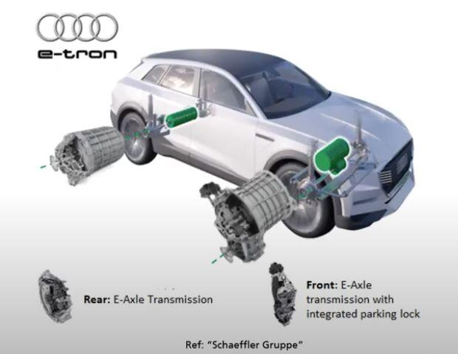

<https://github.com/tui-abdul/NVH_Thesis_Code>

**DevOps and Simulation System Development for Air Traffic Control**

As a working student at e.Sigma, I contributed to the development and integration of an Air Traffic Control (ATC) simulation system, focusing on DevOps and automation. I created a universal development environment using Docker and Bash for both Windows and Linux platforms. Additionally, I developed a cross-platform prototype application and a third-party speech plugin for Microsoft Flight Simulator 2020. This work enhanced simulation efficiency and supported real-time user interaction for training applications.

**Music Genre Classification Using RNN-LSTM**

Developed a deep learning model using Recurrent Neural Networks (RNN) with Long Short-Term Memory (LSTM) units to classify music genres. The model was trained and evaluated on the GTZAN dataset, achieving an accuracy of 80%. The project focused on capturing temporal patterns in audio signals for effective genre identification. This work demonstrated the potential of sequence-based neural architectures in audio signal processing and music classification tasks.

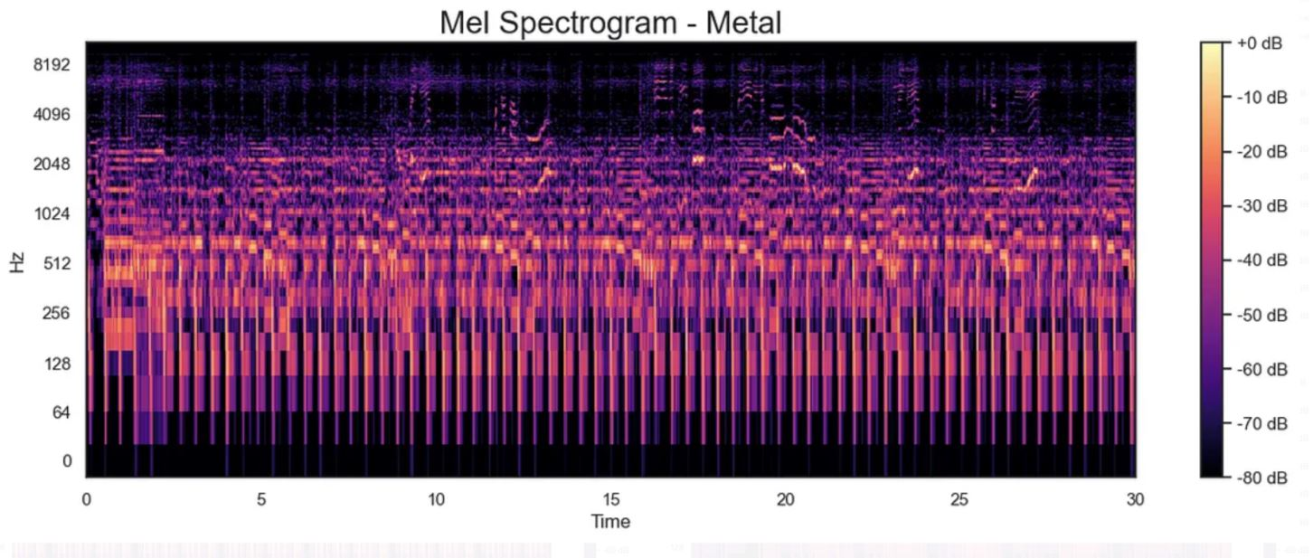

<https://github.com/nouman9311/Music-Genre-Classification>

**Real-Time 3D Hand Tracking Using GAN and RGB Camera**

Designed and implemented a real-time 3D hand tracking system using a single RGB camera, leveraging a Generative Adversarial Network (GAN) architecture. The project focused on API-level integration for efficient deployment in real-world applications. The GAN model accurately estimated 3D hand poses without the need for depth sensors or multi-camera setups. This approach demonstrated the power of generative models for vision-based human-computer interaction.

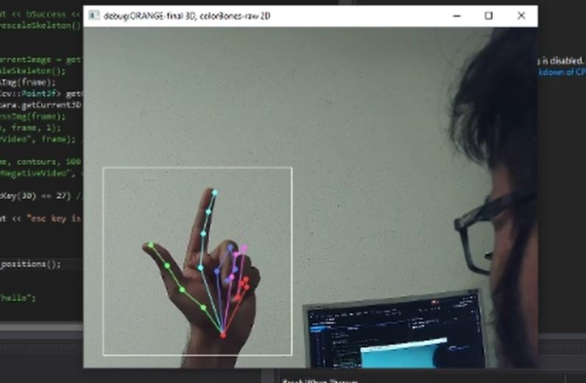



**Just Noticeable Difference in Nearfield VR Interaction**

Developed and evaluated a system in Unity 3D to investigate Just Noticeable Difference (JND) in nearfield interactions within immersive virtual environments. The project aimed to understand perceptual thresholds related to spatial awareness in VR. Findings contribute to improving interaction fidelity and realism in virtual reality systems. This research supports the design of more intuitive and perceptually accurate VR interfaces for future applications. [3]

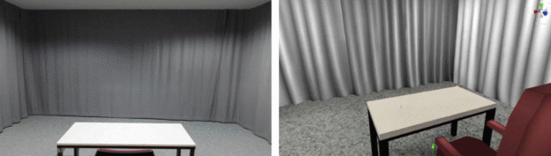

**AR/VR Game Development in Unity 3D**

Developed a location-based augmented reality game using Unity 3D and ARCore mobile application, integrating MapBox for real-world map interactions. Created a virtual reality boxing game, **Punching Bag**, deployed on HTC Vive for immersive fitness-based gameplay. Both projects explored interactive spatial design and motion in AR/VR environments. These applications demonstrated practical use of Unity for engaging, sensor-driven gaming experiences.





**Face Detection with Pan-Tilt Tracking on Raspberry Pi**

Developed a face detection system on Raspberry Pi using a pre-trained Haar Cascade classifier integrated with a pan-tilt servo module. The system tracks faces in real time by adjusting the camera’s orientation based on detected positions. This project demonstrates low-cost, embedded vision capabilities for interactive and surveillance applications. It highlights efficient deployment of computer vision models on resource-constrained hardware.

**References**

[1] Paracha, A. H. A., Brückner, C., Studencki, L. P., & Arbeiter, G. (2025, April). An interactive approach to extrinsically calibrate 3D LiDAR and monocular camera using open source toolchain. In 2025 IEEE International Conference on Simulation, Modeling, and Programming for Autonomous Robots (SIMPAR) (pp. 1-6). IEEE. 10.1109/SIMPAR62925.2025.10978990 2 May 2025

[3] Paracha, A. H. A., Blickensdorff, J., & Johnson, D. S. Assessment and Evaluation of an Unsupervised Machine Learning Model for Automotive and Industrial NVH Applications. ISBN: 978-3-939296-18-8 2 Aug 2021

[2] Fremerey, S., Suleman, M. S., Paracha, A. H. A., & Raake, A. (2020, May). Development and evaluation of a test setup to investigate distance differences in immersive virtual environments. In 2020 Twelfth International Conference on Quality of Multimedia Experience (QoMEX) (pp. 1-4). IEEE. 10.1109/QoMEX48832.2020.9123077 2 May 2020